BANKING MANAGEMENT SYSTEM
AN INDUSTRIAL ORIENTED MINI PROJECT REPORT
Submitted
in the partial fulfillment of the requirements for the award of the degree of
BACHELOR OF TECHNOLOGY
in
COMPUTER SCIENCE AND ENGINEERING
By
B. Pooja(22B81A05AN)
L. Priyanka(23B81A05AK)
S. Shravya(23B81A05BF)

Under the Guidance of
Thatikonda Supraja
Sr. Assistant Professor

DEPARTMENT OF COMPUTER SCIENCE AND ENGINEERING
CVR COLLEGE OF ENGINEERING
(An Autonomous institution, NBA, NAAC Accredited and Affiliated to JNTUH, Hyderabad)
Vastunagar, Mangalpalli (V), Ibrahimpatnam (M),
Rangareddy (D), Telangana- 501 510
April-2026
ACKNOWLEDGEMENT
I would like to express my deep sense of gratitude to the management of CVR College of Engineering for providing the necessary infrastructure to carry out this Industrial Oriented Mini Project.
I am extremely grateful to Dr. A Vani Vathsala, Head of the Department, Computer Science and Engineering, for her constant encouragement and support.
I express my heartfelt gratitude to my project guide, Thatikonda Supraja, Sr. Assistant Professor, Department of CSE, for their invaluable guidance, constant monitoring, and technical support throughout the duration of the project. The success of the project "Banking Management System" would not have been possible without their mentorship.
Finally, I would like to thank my parents and friends for their continuous motivation, which helped me complete this project within the stipulated time.
B. Pooja – 22B81A05AN
L. Priyanka– 23B81A05AK
S. Shravya – 23B81A05BF


CVR COLLEGE OF ENGINEERING
(An UGC Autonomous Institution with NAAC ‘A’ Grade,Affiliated to JNTUH)
Vastunagar, Mangalpalli (V), Ibrahimpatan (M), R.R.District, Telangana

DEPARTMENT OF COMPUTER SCIENCE AND ENGINEERING

CERTIFICATE
This is to certify that the Industrial Oriented Mini project entitled “BANKING MANAGEMENT SYSTEM” being submitted by B.Pooja(22B81A05AN), L.Priyanka(23B81A05AK), S.Shravya(23B81A05BF),in partial fulfillment for the award of Bachelor of Technology in Computer Science and Engineering to the CVR College of Engineering, is a record of bona fide work carried out by them under my guidance and supervision during the year 2025-2026.The results embodied in this Industrial Oriented Mini project work have not been submitted to any other University or Institute for the award of any degree or diploma.

Signature of the project guide Signature of the HOD
Thatikonda Supraja
Sr. Assistant Professor
External Examiner

ABSTRACT

In the contemporary era of digital transformation, the banking sector has transitioned from traditional brick-and-mortar operations to ubiquitous online platforms. While this shift has enhanced user convenience, it has simultaneously introduced sophisticated cybersecurity threats, most notably automated account takeover and rapid fund depletion attacks. Fortis Trust is a proactive, full-stack digital banking management system engineered to address the critical limitations of traditional financial applications that typically react to fraud only after a security breach has occurred.
The system is developed using a decoupled, three-tier RESTful architecture. The frontend is built with React.js 18, providing a dynamic and responsive user interface, while the backend is powered by Spring Boot 3.x, ensuring a high-performance, stateless API environment. Data persistence is managed via MySQL 8.0, utilizing pessimistic locking to maintain ACID (Atomicity, Consistency, Isolation, Durability) compliance during concurrent financial transactions.
The core innovation of Fortis Trust lies in its multi-layered security infrastructure. Identity management is secured through JSON Web Tokens (JWT) and BCrypt hashing for sensitive credentials. Beyond standard authentication, the platform integrates an Automated Fraud Detection Engine that employs real-time heuristics to mitigate risk. This includes Velocity Checks, which monitor and limit transaction frequency to block automated scripts, and Drain Checks, which prevent rapid account depletion by restricting outflows to 90% of the liquid balance within a rolling two-minute window. Furthermore, every financial outflow requires a mandatory, encrypted 6-digit Transaction PIN, establishing a secondary authorization gate.
The platform provides a dual-interface ecosystem: a comprehensive User Dashboard featuring interactive financial health analytics and cash-flow visualizations powered by Chart.js, and an administrative "Intelligence Grid". This command center allows for system-wide oversight, real-time stress monitoring of the global ledger, and a secure bypass mechanism for manual account restoration and unlocking. Ultimately, Fortis Trust serves as a robust prototype for modern fintech, demonstrating that proactive behavioral monitoring and decoupled architectures can significantly enhance the integrity and security of digital financial assets.

Table of Contents
 |  |  | Page No.
1 |  | Introduction
 | 1.1 | Motivation | 1
 | 1.2 | Problem statement | 2
 | 1.3 | Project Objectives | 3
 | 1.4 | Project report Organization | 3
2 |  | Literature Survey
 | 2.1 | Evolution of Digital Banking Architectures | 4
 | 2.2 | Stateless Authentication and JWT Security | 4
 | 2.3 | Heuristic-Based Fraud Detection Mechanisms | 4
 | 2.4 | Limitations of Existing Work and Gap Identification | 5
3 |  | Software & Hardware specifications
 | 3.1 | Software requirements | 6
 | 3.2 | Hardware requirements | 7
4 |  | Proposed System Design
 | 4.0 | Proposed methods | 8
 | 4.1 | System Architecture | 9
 | 4.2 | Class Diagram | 10
 | 4.3 | Use case Diagram | 11
 | 4.4 | Activity Diagram | 12
 | 4.5 | Sequence Diagram | 13
 | 4.6 | Technology Description | 14
5 |  | Implementation & Testing
 | 5.1 | Implementation | 16
 | 5.2 | Testing Methodology | 16
6 |  | Conclusion | 23
7 |  | Future scope | 24
 |  | References | 25

LIST OF TABLES
Table Title Page
3.1.1 Software Requirements.......................................................................................6
3.1.2 Hardware Requirements……………………………………………..................7
LIST OF FIGURES
Figure Title Page
4.0 System Architecture……………………………………………………………...10
4.1 Class Diagram............................................................................... ………………11
4.2 Use Case Diagram..................................................................................................12
4.3 Activity Diagram....................................................................................................13
4.4 Sequence Diagram..................................................................................................14

- INTRODUCTION
The global financial landscape has undergone a radical paradigm shift toward digital ubiquity, replacing traditional brick-and-mortar banking with high-speed, decoupled web applications. While this transition to Fintech has provided unprecedented convenience for wealth management, it has simultaneously introduced sophisticated cybersecurity risks, specifically automated account takeovers and financial depletion attacks. Current industry statistics indicate that most contemporary banking prototypes focus heavily on user journey and interface design while remaining largely reactive in their security posture—flagging fraud only after a financial loss has occurred. Fortis Trust is engineered to address these systemic challenges by establishing a proactive banking environment that integrates advanced behavioural monitoring directly into the financial ledger.
Unlike standard banking applications that act only after a security breach, Fortis Trust implements an "Internal Behavioural Firewall" designed to stop unauthorized fraud scripts in real-time. By utilizing a decoupled architecture with React.js and Spring Boot, the system maintains high-performance stateless scalability while enforcing strict behavioral heuristics such as Velocity Controls and Drain Pattern Analysis. These specific mechanisms monitor transaction frequency and account volume, effectively blocking unauthorized access attempts even if primary login credentials have been compromised. Ultimately, this project establishes a robust prototype for secure digital wealth management, proving that the integration of behavioural monitoring and modern technical frameworks can significantly reduce the vulnerability window for digital financial crimes.
  - Motivation
The global financial landscape has undergone a radical paradigm shift toward digital ubiquity. With the rapid expansion of FinTech (Financial Technology), traditional brick-and-mortar banking has been replaced by high-speed, decoupled web applications. While this transition has provided unprecedented convenience to users, it has simultaneously opened new frontiers for sophisticated financial cyber-crimes.
Current statistics indicate that automated scripts and "Account Takeover" (ATO) attacks are increasing in both frequency and complexity. Most mid-sized banking applications focus heavily on the User Interface (UI) but remain reactive in their security approach flagging fraud only after the financial loss has occurred. The primary motivation behind Fortis Trust is to engineer a proactive banking environment. By integrating real-time behavioural heuristics specifically Transaction Velocity and Drain Pattern Analysis this project aims to create an "Internal Behavioural Firewall." The goal is to provide a system that doesn't just record transactions but actively defends them, ensuring that user assets are protected even in the event of primary credential compromise.

  - Problem statement
Existing digital banking platforms, particularly those developed at an enterprise-prototype level, often suffer from three critical vulnerabilities:
Passive Security Models: Most applications rely on static authentication (login/password) and do not monitor user behaviour post-login. If a session is hijacked, there are no internal triggers to stop a script from rapidly transferring out the entire account balance.
Lack of Real-Time Heuristics: Standard systems do not calculate the "Velocity" of transactions. They allow an unlimited number of transfers as long as the balance is sufficient, making them susceptible to automated "Draining" attacks.
Fragmented Administrative Oversight: There is often a gap between the user’s activity and the administrator’s ability to intervene. Admins frequently lack a centralized "Command Center" or "Intelligence Grid" to monitor system-wide stress, identify blocked nodes, or restore access to restricted accounts through a secure bypass mechanism.
  - Project Objectives
The primary objective of this project is to develop a secure, full-stack digital banking ecosystem that balances high-end security with a modern user experience. The specific objectives are as follows:
- To Architect a Decoupled RESTful System: Utilizing React.js for a dynamic frontend and Spring Boot for a stateless, high-performance backend API.
- To Implement Stateless Authentication: Using JSON Web Tokens (JWT) to ensure that every request is cryptographically verified without the overhead of server-side sessions.
- To Engineer a Fraud Detection Engine: Developing services that calculate transaction frequency (Velocity) and account depletion rates (Drain Check) in real-time.
- To Ensure Data Integrity and Concurrency: Leveraging MySQL 8.0 with Pessimistic Locking to maintain ACID compliance during simultaneous fund transfers.
- To Provide Data-Driven Insights: Generating interactive financial health scores and cash-flow analytics for users using Chart.js.
- To Establish an Administrative Intelligence Grid: Building a high-density oversight dashboard for system monitoring, global ledger search, and account restoration.

  - Project Report Organization
The project report is organized into six distinct chapters, each focusing on a specific phase of the development lifecycle:
- Chapter 1 (Introduction): Provides the motivation, problem statement, and core objectives of the system.
- Chapter 2 (Literature Survey): Explores the evolution of banking architectures, stateless security patterns, and existing fraud detection methodologies.
- Chapter 3 (Specifications): Details the hardware and software requirements necessary to host and develop the platform.
- Chapter 4 (Proposed System Design): Presents the UML diagrams, including Use Case, Class, Activity, and Sequence diagrams, along with the detailed system architecture.
- Chapter 5 (Implementation & Testing): Discusses the functional modules of the code and presents the results of unit and security testing through various test cases.
- Chapter 6 (Conclusion & Future Scope): Summarizes the project's achievements and outlines potential enhancements, such as AI integration and Biometric authentication.
.

- LITERATURE SURVEY
  - EVOLUTION OF DIGITAL BANKING ARCHITECTURES
The landscape of financial technology has undergone a significant paradigm shift from traditional, centralized monolithic systems to decentralized, decoupled web architectures. In the early stages of digital banking, systems were primarily stateful, relying on server-side session management to track user activity. As noted by industry research, these architectures faced significant scalability challenges during high-traffic periods and were prone to "Session Fixation" attacks.
The emergence of the Single Page Application (SPA) model, combined with stateless RESTful APIs, has revolutionized the user experience. By offloading UI rendering to the client side and using JSON as a lightweight data interchange format, modern systems can provide real-time updates and complex data visualizations without the overhead of full-page reloads. This architectural evolution serves as the foundation for the Fortis Trust platform.

  - STATELESS AUTHENTICATION AND TOKEN-BASED SECURITY
Security in digital banking has transitioned from simple password-based authentication to multi-layered, token-based protocols. Literature regarding web security frequently highlights the vulnerabilities of "Cookies" and "Sessions" in cross-origin environments. The introduction of JSON Web Tokens (JWT) addressed these concerns by providing a compact, URL-safe means of representing claims between two parties.
2.3 HEURISTIC-BASED FRAUD DETECTION MECHANISMS
Fraud detection in banking has traditionally been a reactive process, where suspicious activities are flagged only after the financial loss has occurred. Recent academic studies on "Cyber-Financial Heuristics" emphasize the importance of proactive, rule-based monitoring. Two critical metrics identified in the literature are Transaction Velocity and Account Volume Analysis.
- Velocity Tracking: This involves monitoring the frequency of transactions within a specific temporal window. Research indicates that automated scripts used in "Account Takeover" (ATO) attacks often execute multiple small-value transfers in quick succession to bypass traditional daily limits.
- Drain Pattern Analysis: This heuristic monitors the percentage of liquid assets being moved relative to the total account balance. A rapid depletion of over 90% of a user's funds within a two-minute window is a high-confidence indicator of unauthorized access.

2.4 LIMITATIONS OF EXISTING WORK AND GAP IDENTIFICATION
A comprehensive review of existing digital banking prototypes and entry-level financial management systems reveals several critical technical and security limitations. While most contemporary projects successfully implement basic "CRUD" (Create, Read, Update, Delete) operations for account management, they frequently lack a proactive defence posture. The identified gaps in existing literature and implementations are categorized as follows:
- Passive Security Models: Most existing student-level banking projects rely solely on static authentication (login credentials) and SSL/TLS for data in transit. There is a significant lack of behavioural monitoring post-login. If a user's session is hijacked, these systems do not implement an "Internal Firewall" to monitor transaction patterns, leaving the account vulnerable to unauthorized fund movement.
- Absence of Transaction Heuristics: A notable gap exists in the implementation of "Velocity" and "Volume" heuristics. Traditional systems typically allow an unlimited number of transfers as long as the liquid balance is sufficient. They do not calculate the frequency of requests (Velocity) or the ratio of account depletion (Drain Check) in real-time, making them highly susceptible to automated fraud scripts.
- Fragmented Administrative Oversight: In existing work, administrative features are often limited to basic user management. There is a lack of high-density "Intelligence Grids" that provide real-time visual analytics of global system stress, net cash flow, or a secure "Bypass" mechanism for restoring accounts that have been restricted by automated security triggers.
- Concurrency Vulnerabilities: Many academic banking implementations do not adequately address the "Lost Update" problem. Without the use of sophisticated database-level Pessimistic Locking, these systems are vulnerable to race conditions where simultaneous transaction requests can lead to financial discrepancies and inaccurate account balances.
Fortis Trust is specifically engineered to bridge these identified gaps by integrating a proactive Fraud Detection Engine and a decoupled administrative oversight grid into a stateless, high-concurrency architecture.

- SOFTWARE & HARDWARE SPECIFICATIONS
3.1 Software Requirements

Category | Component | Specification
Operating System | Windows / Linux | Windows 10/11 or Ubuntu 22.04 LTS
Programming Languages | Java & JavaScript | JDK 17 (LTS), ES6+ JavaScript
Backend Framework | Spring Boot | Version 3.2.x with Embedded Tomcat
Frontend Library | React.js | Version 18.x (Functional Components)
Database Management | MySQL Server | Version 8.0 (Relational Storage)
Security Layer | Spring Security | JWT (JSON Web Tokens) & BCrypt
UI Styling | Tailwind CSS | Utility-first CSS framework
Data Visualization | Chart.js | react-chartjs-2 for interactive graphs
API Testing Tool | Postman | REST API validation and testing
Version Control | Git | Distributed Version Control System

Table 3.1.1: Software Requirements

3.2 Hardware Requirements
Component | Minimum Requirement | Recommended Specification
Processor (CPU) | Intel Core i5 (8th Gen) | Intel Core i7 or AMD Ryzen 7
System Memory (RAM) | 8 GB DDR4 | 16 GB DDR4
Hard Disk (Storage) | 20 GB available space | 256 GB SSD (Solid State Drive)
Display Resolution | 1366 x 768 | 1920 x 1080 (Full HD)
Input Devices | Standard Keyboard & Mouse | High-precision peripherals
Network Interface | 10 Mbps Broadband | 50 Mbps Fiber (for SMTP/Maven)

Table 3.1.2: Hardware Requirements

4. PROPOSED SYSTEM DESIGN
The architecture of Fortis Trust is engineered as a Three-Tier Decoupled Client-Server Model, designed to prioritize security, statelessness, and high-concurrency handling. Unlike traditional monolithic systems where the user interface and business logic are tightly coupled, this system maintains a strict separation of concerns. This architectural choice ensures that the frontend can be scaled or updated independently of the backend API, and vice versa.
Frontend Tier: Single Page Application (SPA)
The presentation layer is implemented as a Single Page Application (SPA) using the React.js 18 library. The primary advantage of an SPA architecture in a banking context is the elimination of full-page reloads, which provides a seamless, app-like experience for the user.
- Component-Based Design: The UI is decomposed into reusable functional components (e.g., StatCard, TransactionTable), which utilize React Hooks (useState, useEffect) to manage local states and side effects.
- Asynchronous Communication: The frontend utilizes the Axios library to perform non-blocking HTTP requests to the backend. This allows the financial dashboards and real-time "Intelligence Grids" to update dynamically as data arrives from the REST endpoints.
Logic Tier: Spring Boot RESTful API
The middle tier serves as the "brain" of the system, developed using the Spring Boot 3.x framework. It acts as a stateless service provider that processes incoming requests and returns data in a lightweight JSON (JavaScript Object Notation) format.
- Service-Oriented Logic: The backend is divided into specialized services, most notably the AccountService and FraudDetectionService. This modularity ensures that the "Internal Firewall" heuristics (Velocity and Drain checks) are applied globally across all transaction endpoints.
- Atomic Operations: To ensure data integrity, the system uses the @Transactional annotation. This guarantees that if any part of a fund transfer fails (e.g., the receiver's account is not found), the entire operation is rolled back, preventing "phantom" balance updates.
Security Tier: Stateless JWT Architecture
Security is enforced at the entry point of the application tier using Spring Security and a custom JwtFilter.
- Statelessness: The system does not utilize server-side sessions (HttpSession). Instead, it follows a token-based authentication pattern. Intercept-and-Verify: For every subsequent request, the JwtFilter intercepts the "Authorization: Bearer".

4.1 System Architecture
The architecture of Fortis Trust is engineered as a vertical, three-tier decoupled client-server model, designed to ensure a strict separation of concerns between the user interface, business logic, and data persistence. At the uppermost level, the Presentation Tier is implemented as a Single Page Application (SPA) using React.js 18, which manages the application state and provides a responsive user experience. This layer utilizes the Axios HTTP client to capture user inputs and dispatch them downward to the application logic via asynchronous REST/JSON calls. By offloading UI rendering to the client side, the system achieves high performance and reduces server-side overhead, allowing for seamless navigation through financial dashboards and interactive analytics.
The middle tier serves as the Application Logic Layer, powered by Spring Boot 3.x, which acts as the central engine of the system. This tier is characterized by its "Security & Fraud Gates," a specialized perimeter that intercepts every incoming request to verify cryptographic identity through a JWT Auth Filter and behavioural safety through the Fraud Detection Engine. Once a request passes these heuristic checks, it is processed by the core Spring Boot Services, which execute the banking business logic. Finally, the Data Tier handles the persistence of the global ledger using a MySQL database managed by Spring Data JPA. This bottom layer ensures that all financial operations are atomically updated and durably committed, maintaining 100% data integrity and ACID compliance throughout the transaction lifecycle.

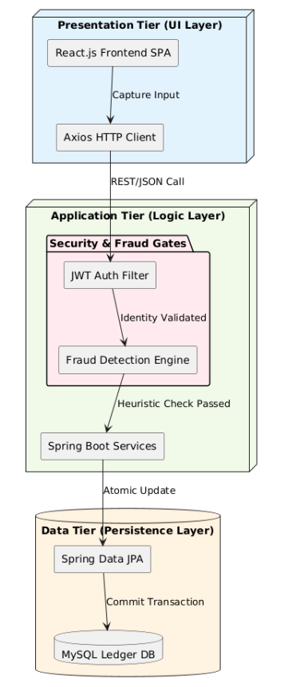
Fig 1: System Architecture

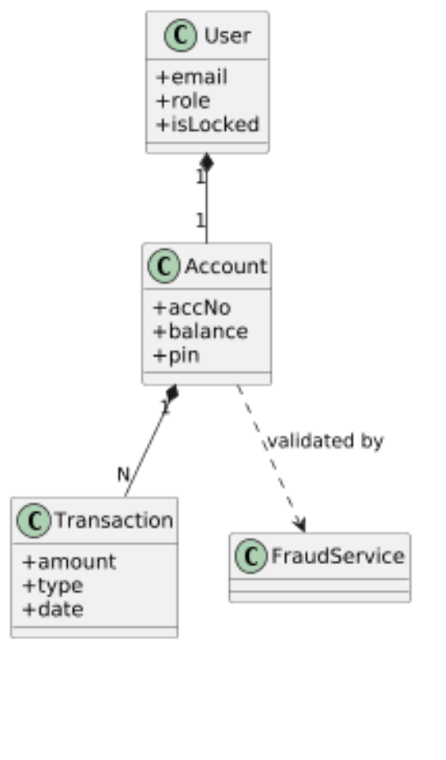
4.2 Class Diagram
Fig 2: Class Diagram

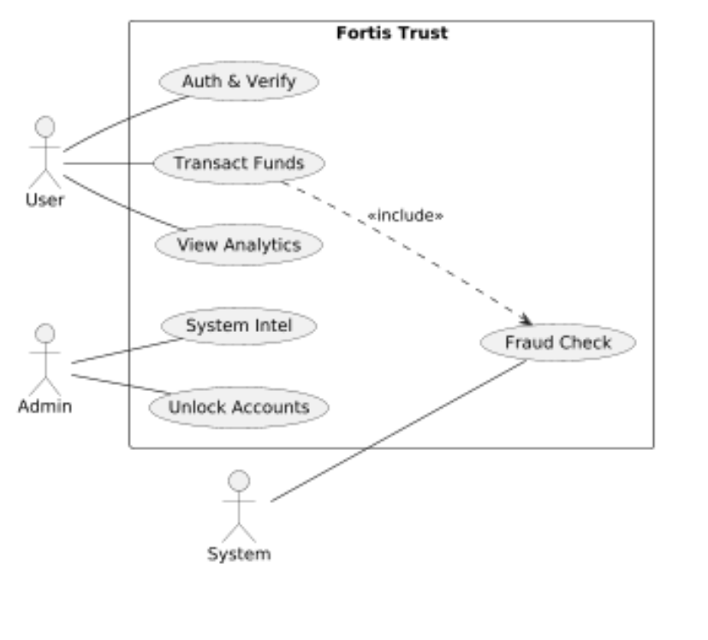
4.3 Usecase Diagram

Fig 3: Usecase Diagram

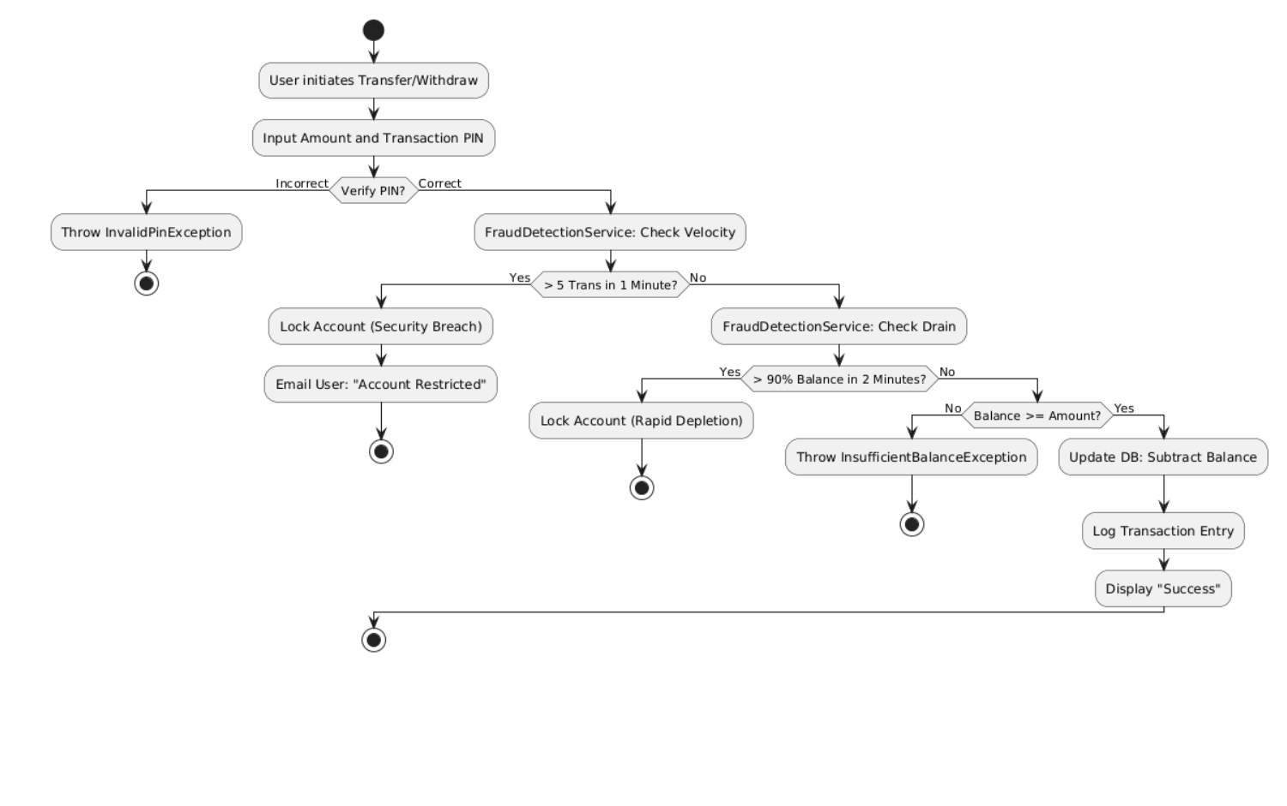
4.4 Activity Diagram

Fig 4: Activity Diagram

4.5 Sequence Diagram

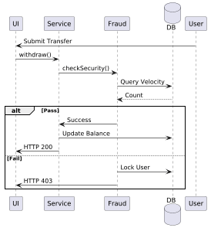
Fig 5: Sequence Diagram
4.6 TECHNOLOGY DESCRIPTION
The implementation of Fortis Trust relies on a modern, high-performance technology stack designed to handle sensitive financial data. The following core technologies and patterns are utilized to ensure the system’s security, reliability, and responsiveness.
Stateless Authentication via JSON Web Tokens (JWT)
In traditional web applications, user sessions are maintained on the server using JSESSIONID and HttpSession. However, to ensure high scalability and prevent server-side memory bottlenecks, Fortis Trust implements a Stateless JWT Architecture.
- Token Anatomy: Each JWT consists of a Header (specifying the algorithm), a Payload (containing user email and roles), and a Signature (generated using a 256-bit secret key).
- Security Benefit: Once the server issues a token, it does not need to store it in a database or memory. The JwtFilter verifies every incoming request by checking the token's cryptographic signature. This approach effectively prevents Cross-Site Request Forgery (CSRF) and allows the application to handle thousands of concurrent users across multiple cloud nodes without losing session data.
Proactive Fraud Detection Service
The Fraud Detection Service is a specialized, Spring-managed singleton service that acts as a behavioural gatekeeper for the banking ledger. Unlike traditional "post-facto" security, this service executes a "Pre-Commit" check before any financial record is written to the database.
- Velocity Heuristics: The service interacts with the TransactionRepository to query the ledger for the specific user’s activity within the last 60 seconds. By calculating the frequency of recent transactions, it enforces a Velocity Rule (Maximum 5 transactions per minute).
- Behavioural Blocking: If the service detects that a user is attempting to move funds faster than the human threshold allows, it assumes an automated script-based attack is in progress. The service then triggers an immediate Account Lock by setting the accountNonLocked flag to false in the database and throwing a SecurityViolationException, which halts the transaction immediately.
Atomic Transaction Management (@Transactional)
Financial integrity depends on the "All-or-Nothing" principle of transactions. Fortis Trust utilizes the Spring Framework’s @Transactional annotation to enforce ACID (Atomicity, Consistency, Isolation, Durability) properties during fund transfers.
- Transfer Atomicity: A fund transfer involves two distinct operations: subtracting from the sender and adding to the receiver. Without atomicity, a system crash between these two steps would result in money "disappearing."
- Rollback Mechanism: The @Transactional wrapper ensures that if the second operation fails for any reason (e.g., recipient account not found or database timeout), the first operation is automatically "Rolled Back." This keeps the global ledger in a consistent state and prevents any loss of data integrity.
React-Driven Asynchronous Rendering
The frontend utilizes React.js 18 to maintain a high-density, real-time dashboard.
- Virtual DOM: React’s Virtual DOM allows the "Intelligence Grid" to update transaction lists and growth charts efficiently without a full-page refresh.
- State Management: By using React Hooks (useState, useEffect), the system maintains a live connection with the REST API. This ensures that the user's "Stability Index" and balance updates are reflected the moment the backend commits a transaction.
5. IMPLEMENTATION & TESTING
  - Implementation Of Functional Modules
Fortis Trust is implemented using a decoupled architecture consisting of a React.js frontend and a Spring Boot REST API. Security is established through JWT stateless authentication and BCrypt hashing for sensitive credentials. Core banking operations utilize the Spring @Transactional annotation and database-level Pessimistic Locking to ensure atomic integrity and prevent race conditions during fund transfers. The system’s primary innovation is a proactive Fraud Detection Service that evaluates real-time heuristics, including Velocity Checks to block automated scripts and Drain Analysis to prevent rapid account depletion. Finally, the application integrates Chart.js for asynchronous data visualization, providing users and administrators with real-time financial analytics and system oversight.

  - Testing Methodology
The testing phase for Fortis Trust utilized a multi-layered approach to ensure financial accuracy and security integrity. Core backend services and atomic transaction rollbacks were validated using the JUnit 5 framework to ensure 100% data consistency during fund transfers. Proactive security heuristics were verified through behavioral stress testing, confirming that the Fraud Detection Engine successfully restricts accounts upon exceeding velocity (>5 trans/min) or drain (>90% balance) thresholds. Finally, integrated system testing was performed to ensure seamless REST API communication between the React.js frontend and Spring Boot backend, with all functional requirements meeting the success criteria defined in the project objectives.

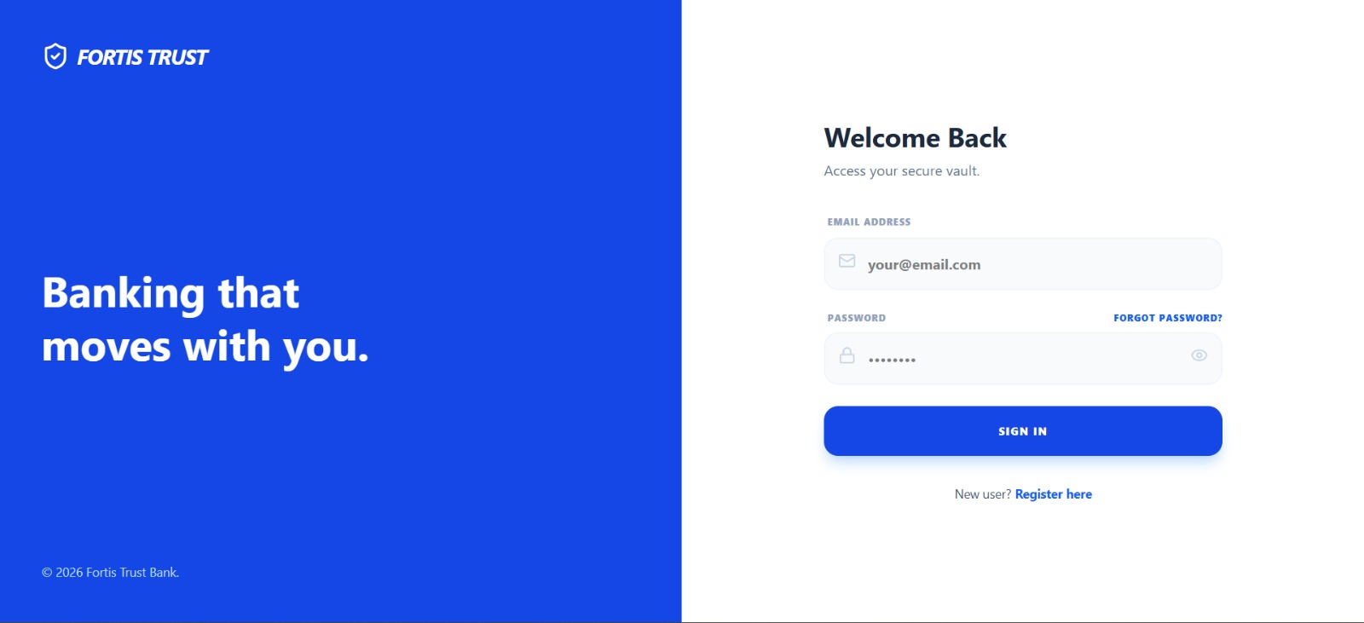
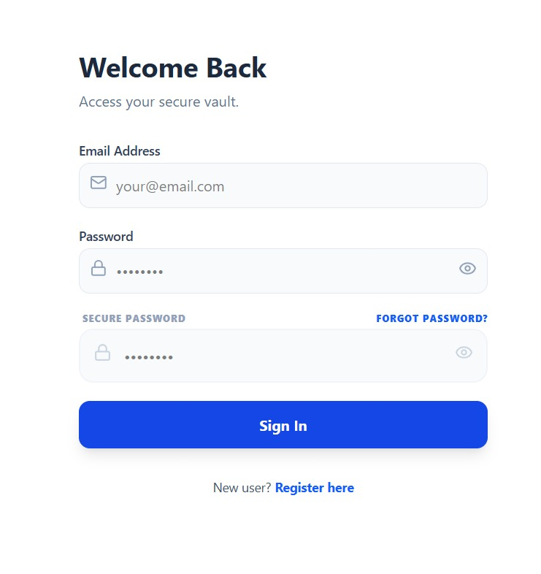
Fig 6: Login Page
Fig 7: Forgot Password Page
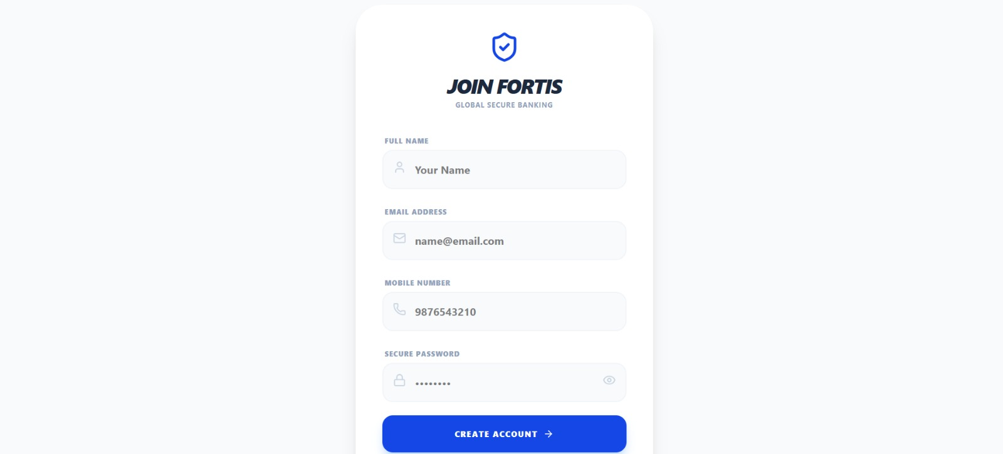
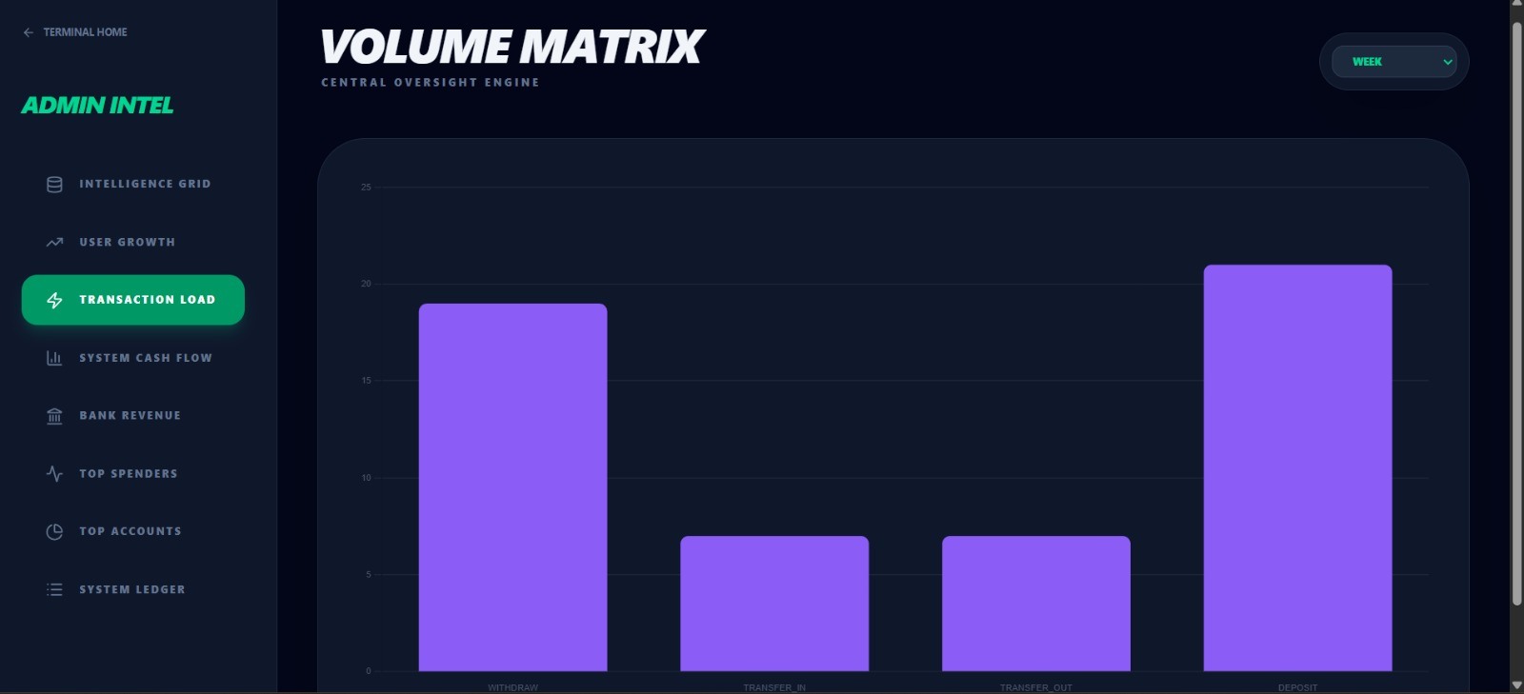
Fig 8: User Registration Page

Fig 9: Admin Analytics- Transaction Load

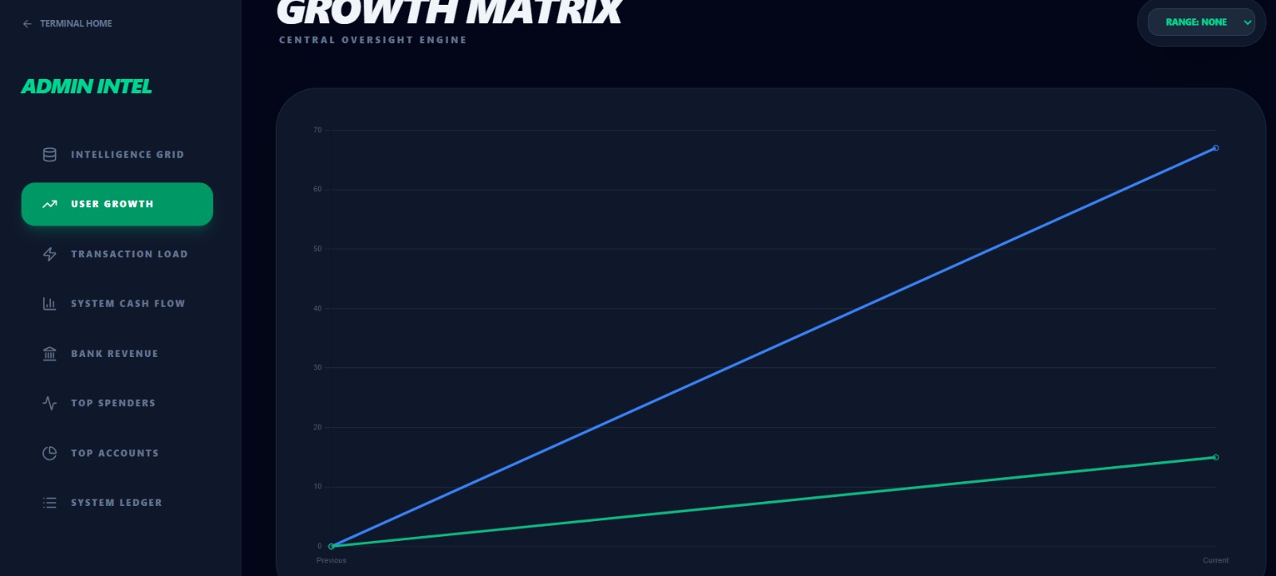
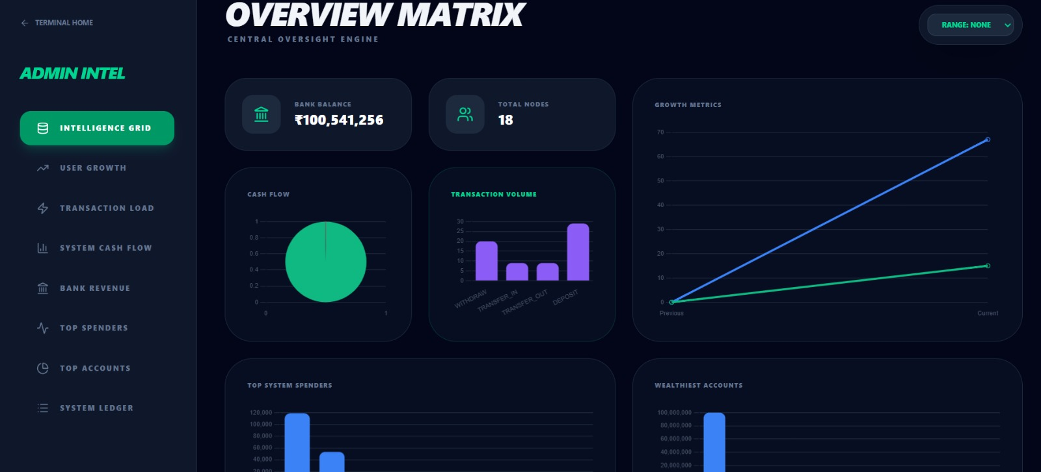
Fig 10: Admin Analytics- User Growth

Fig 11: Admin Analytics- Intelligence Grid
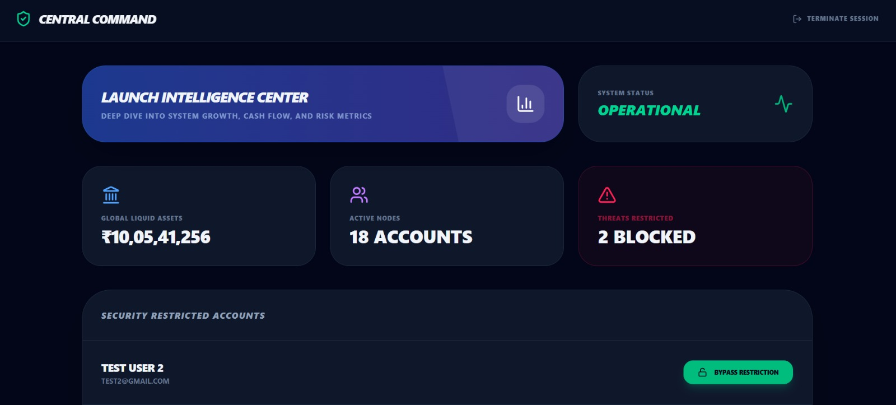

Fig 12: Admin Dashboard

Fig 13: Transaction PIN Reset Page

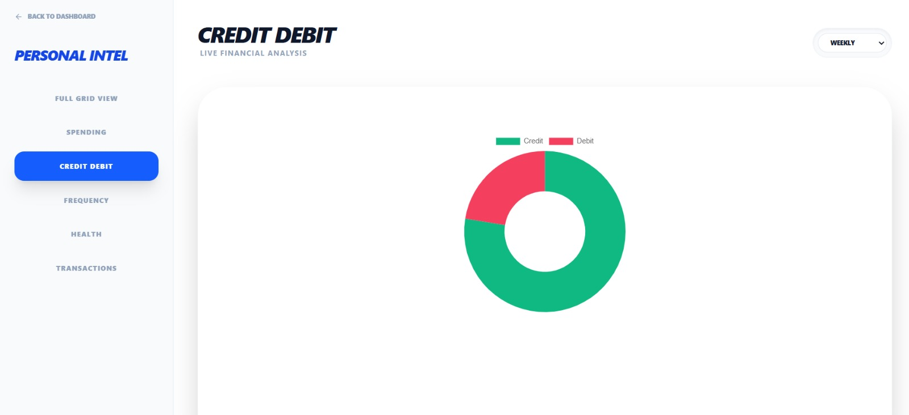
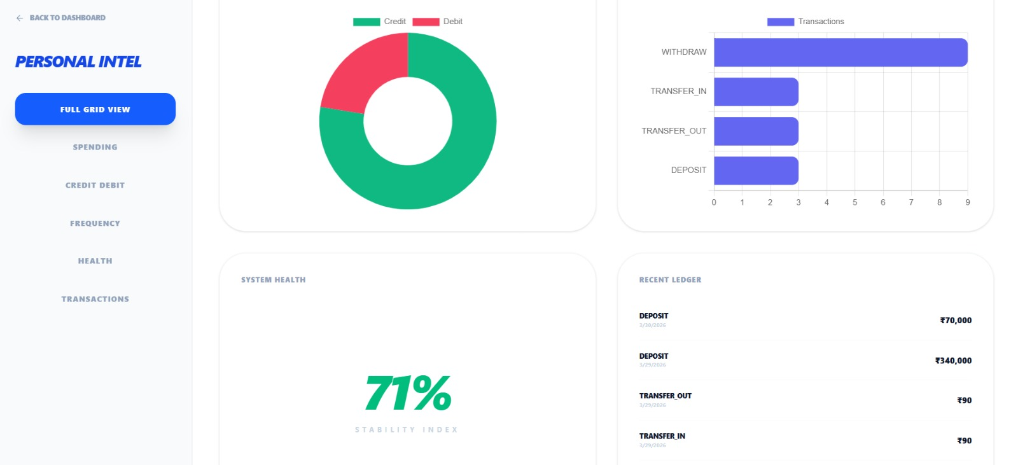
Fig 14: User Analytics- Credit Debit

Fig 15: User Analytics- Full Grid View
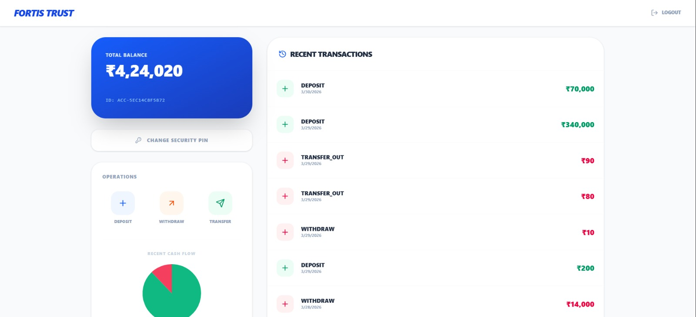
Fig 16: Transaction History of User

6. CONCLUSION
The development of Fortis Trust successfully demonstrates that high-level financial security and a seamless user experience are not mutually exclusive; the project advances beyond standard "Banking CRUD" applications by introducing a proactive security layer, dubbed an Internal Firewall, which is specifically designed to mitigate the risks of automated attacks and session hijacking. Through a decoupled architecture utilizing React.js and Spring Boot, the system achieves high performance and stateless scalability, complemented by JSON Web Tokens (JWT) that ensure every API request is cryptographically verified for identity and authorization.
Acting as a behavioural gatekeeper, the Fraud Detection Engine effectively implements two critical security heuristics: Velocity Control, which prevents rapid, script-based fund transfers by limiting transaction frequency, and Drain Protection, which detects and blocks attempts to deplete account balances within a short window a common pattern in digital theft. Furthermore, the dual-interface design offers a holistic view of the banking ecosystem, providing users with deep insights into their financial health via Chart.js analytics while empowering administrators with an Intelligence Grid to monitor system-wide stress and manage restricted accounts. Ultimately, Fortis Trust serves as a robust prototype for modern fintech applications, proving that proactive, rule-based security can significantly reduce the window of opportunity for digital fraud.

  - FUTURE SCOPE
While the current version of Fortis Trust provides a solid foundation for secure digital banking, several advanced features can be integrated to move it toward a production-grade enterprise system:
- AI and Machine Learning Integration:
The current fraud detection system relies on static rules (e.g., 5 transactions per minute). Future iterations will replace these with Anomalous Behavior Detection (ABD) models. By using libraries like TensorFlow.js or Weka, the system can learn a user’s unique spending patterns and flag transactions that deviate from the norm, even if they don't break static rules.
- Biometric Authentication via WebAuthn:
To eliminate the vulnerability of static PINs, the application can implement the FIDO2/WebAuthn API. This would allow users to authorize high-value transfers using hardware-based biometrics such as TouchID, FaceID, or USB security keys (YubiKeys) directly from the browser.
- Blockchain-Based Immutable Ledger:
To enhance transparency and prevent internal database tampering, the transaction history could be mirrored onto a Private Blockchain (Hyperledger Fabric). This would ensure that once a transaction is recorded, it is mathematically impossible to alter or delete, providing an absolute audit trail for regulators.
- Microservices and Cloud Orchestration:
As the user base grows, the monolithic Spring Boot backend can be decomposed into Microservices (Auth-Service, Transaction-Service, Analytics-Service). Deploying these via Docker and Kubernetes would allow the system to scale specific modules based on real-time traffic demand.
- Multi-Currency and Cross-Border Payments:
Integrating with third-party Exchange Rate APIs (like Fixer.io) would enable multi-currency support. This would involve complex logic for real-time currency conversion and compliance with international banking standards (ISO 20022).
REFERENCES
[1] Banks, A. and Porcello, E. (2020) Learning React: Modern Patterns for Developing React Apps. O’Reilly Media, 2nd Edition.
[2] Bloch, J. (2018) Effective Java. Addison-Wesley Professional, 3rd Edition.
[3] Fielding, R. T. (2000) Architectural Styles and the Design of Network-based Software Architectures. University of California. [Online]. Available: https://www.ics.uci.edu/~fielding/pubs/dissertation/top.htm.
[4] IETF (2015) JSON Web Token (JWT). Request for Comments: 7519, Internet Engineering Task Force. [Online]. Available: https://datatracker.ietf.org/doc/html/rfc7519.
[5] Keith, M. and Schincariol, M. (2018) Pro JPA 2 in Java EE 8: An In-Depth Guide to Java Persistence APIs. Apress Media.
[6] Kleppmann, M. (2017) Designing Data-Intensive Applications. O’Reilly Media.
[7] Martin, R. C. (2017) Clean Architecture: A Craftsman's Guide to Software Structure and Design. Prentice Hall.
[8] Mesbah, A. (2023) Architecting Modern Web Applications. Delft University Press. [Online]. Available: https://modernweb.dev/guide/.
[9] Newman, S. (2021) Building Microservices. O’Reilly Media, 2nd Edition.
[10] OWASP Foundation (2021) OWASP Top 10:2021 The Most Critical Web Application Security Risks. [Online]. Available: https://owasp.org/www-project-top-ten/.
[11] Richardson, C. (2018) Microservices Patterns: With examples in Java. Manning Publications.
[12] Silberschatz, A., Korth, H. F., and Sudarshan, S. (2019) Database System Concepts. McGraw-Hill Education, 7th Edition.
[13] Späth, P. (2019) Spring Security: Authentication and Advanced Customization. Apress Publishing.
[14] Varanasi, S. and Belida, S. (2020) Spring REST: Modern Guide to XML and JSON. Apress Publishing.
[15] Walls, C. (2022) Spring in Action. Manning Publications, 6th Edition.

